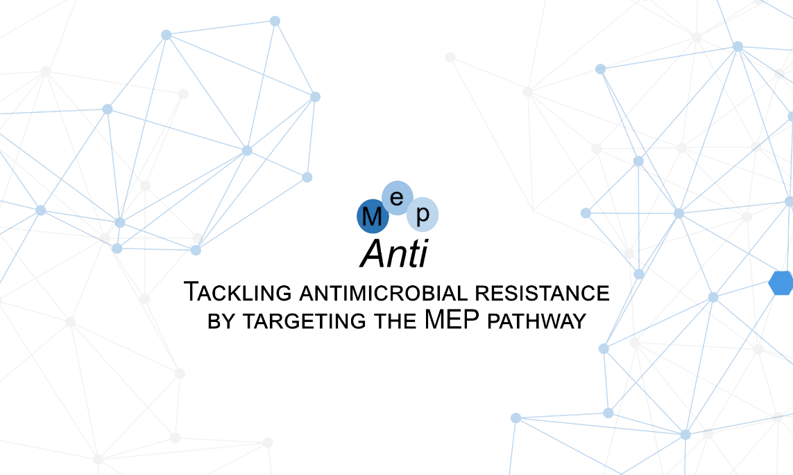

Thank you very much for you interest in The MepAnti Drug Discovery and Development Symposium – Young Researchers. Below you will find guideline on how to register for the symposium. We are looking forward to seeing you there!
Please start with saving this Word template on your computer and then use the saved file to prepare your registration form. Name your registration form "LastnameFirstname UniversityAbbreviation" (example: GreenJessica UiT). It should be sent as a PDF document to mepanticonference2023@gmail.com
For registration, please fill out the following questions and attach your abstract text as mentioned below.

- First name: Last name:

- Institution or company: Your position:

- Country: City:

- Email:

- Area of study:

Abstract text
The maximum size for the abstract is 1 page (A4 format, 210×297 mm) including figures and references.
Please check your registration form carefully before submission. Submissions not conform to the rules will not be considered.

Title of presentation (Calibri 16 points)
First Author (presenting author underscored), Second Author*, Third Author** and Fourth Author (Calibri 12 points)
Affiliation, *Affilitation, ** Affilitation (Calibri 10 points)
Text (Calibri 12 point).

Sources:
(Example, Calibri 12 point)
1) Green.J, et al, Journal, Year, Volume, Pages, DOI

