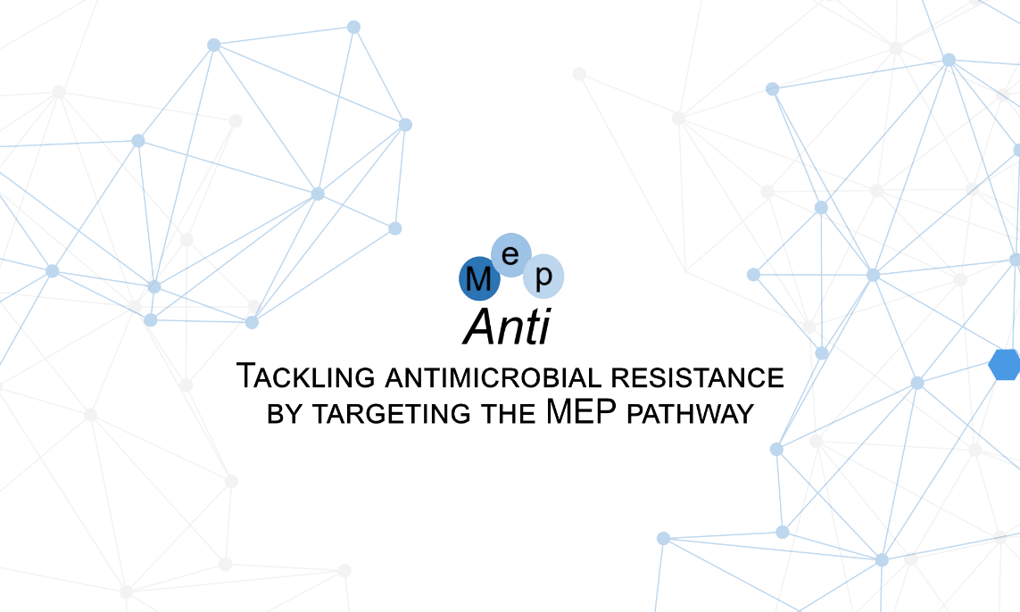

Thank you very much for your interest in the MepAnti Drug research symposium: Young Minds, Big Impact. Below you will find guidelines on how to apply for the symposium. We are looking forward to seeing you there!
Please start with saving this Word template on your computer and then use the saved file to prepare your application form. Name your application form "LastnameFirstname UniversityAbbreviation" (example: SmithJames UDS). It should be sent as a PDF document to mepanticonference2023@gmail.com
For application, please fill out the following questions and attach your abstract text as mentioned below.
Be aware, When the number of applications exceeds the limit, we are compelled to choose a selection of participants! Only after the deadline, we will confirm your application for participating.

- First name: Last name:

- Institution or company: Your position:

- Country: City:

- Email:

- Area of study:

- Dietary requirements:

Abstract text
Please refer to the template below for abstract submission. Abstract should be maximum 1 page long. People who submit an abstract get priority in the selection process.

Title of presentation (Calibri 16 points)
First Author (presenting author underscored), Second Author*, Third Author** and Fourth Author (Calibri 12 points)
Affiliation, *Affilitation, ** Affilitation (Calibri 10 points)
Text (Calibri 12 point).

Sources:
(Example, Calibri 12 point)
1) Smith.J, et al, Journal, Year, Volume, Pages, DOI

